Scenario-Based Exercise – 95% Confidence Interval
Unit 8 – Scenario-Based Exercise: Comparison of Training Vendors
In this exercise, I used R to compare employee efficiency scores following training delivered by three different vendors. I first entered the scores for each vendor and calculated the mean efficiency scores. Vendor 2 had the highest mean score (51.00), followed by Vendor 1 (44.71) and Vendor 3 (27.71).
As the analysis involved three independent groups, I used a Kruskal–Wallis test to determine whether there was a statistically significant difference between the groups. The test showed a significant overall difference (χ²(2) = 12.809, p = 0.001654), meaning the null hypothesis was rejected at the 95% significance level.
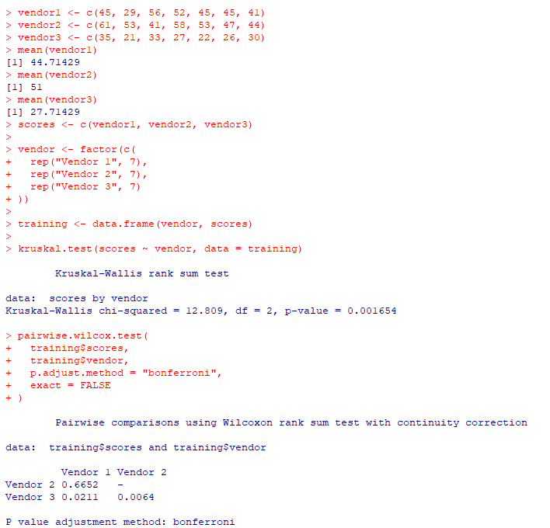
I then performed pairwise Wilcoxon rank-sum tests with Bonferroni adjustment to identify where the differences occurred. Significant differences were found between Vendor 1 and Vendor 3 (p = 0.0211) and between Vendor 2 and Vendor 3 (p = 0.0064). There was no significant difference between Vendor 1 and Vendor 2 (p = 0.6652). Therefore, although Vendor 2 achieved the highest mean score, its performance was not statistically significantly different from Vendor 1.

